White Paper

Sub-Threshold Design - A Revolutionary Approach to Eliminating Power

Issued in May 2014

The contents of this White Paper are protected by

copyright and must not be reproduced without

permission

© 2014 Ambiq Micro. All rights reserved

Sub-Threshold Design - A Revolutionary Approach to Eliminating Power

Sub-Threshold Design - A Revolutionary Approach to Eliminating Power

Low energy consump/on has replaced performance as the foremost challenge in electronic design. Performance is important, but it must now accede to the energy capacity of ba;eries and even the minimal output of energy harvesters. Performance at all costs no longer works; energy consump/on is now the dominant requirement. While reducing energy consump/on is cri/cally important throughout the electronics industry, the ques/on is: how should that goal be achieved? Ambiq Micro’s approach moves beyond the incremental improvements that other semiconductor companies have taken and makes revolu/onary advances through a unique approach to the problem: sub-­‐threshold circuit design.

Energy is consumed in two fundamental ways: as leakage, when a circuit’s state isn’t changing, and dynamically as internal nodes are charged up and down. For realis/c circuits in opera/on, dynamic power
dominates – especially for the higher power supply voltages used in most designs today (see Figure 1 below).
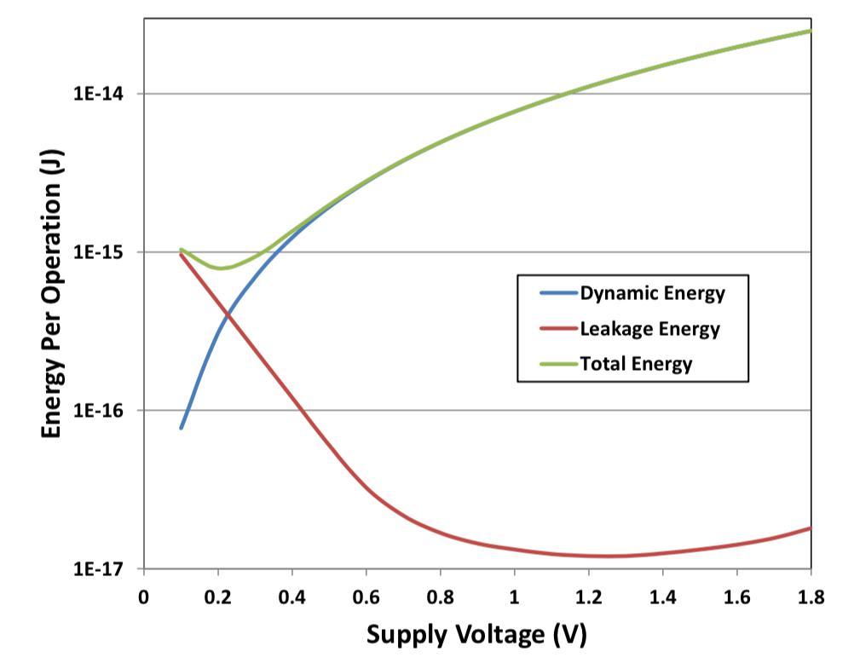

Figure 1: Dynamic current dominates with higher opera7ng voltage

Because dynamic energy varies as the square of the opera/ng voltage, that voltage becomes the biggest lever for reducing dynamic energy consump/on (while also having a tangible, but less drama/c, impact on leakage). For example, when compared to a typical circuit opera/ng at 1.8V, a “near-­‐threshold” circuit opera/ng at 0.5V can achieve up to a 13X improvement in dynamic energy. An even more aggressive “sub-­‐threshold” circuit opera/ng at 0.3V can achieve up to a 36X improvement!

Tradi/onal digital designs use the transistor state – “on” or “oﬀ” – as a cri/cal concept for implemen/ng logic. Analog designs likewise

assume that a transistor is “on” to some controlled degree, using it for amplifica/on. But sub-­‐threshold opera/on means that none of the voltages in the chip rise above the threshold voltage (V_{th}), so the

transistors never turn on. Even a logic “high” voltage keeps the transistors “oﬀ.” This means that completely new design approaches are required.

!2

Sub-Threshold Design - A Revolutionary Approach to liminating Power

This whitepaper examines the challenges of sub-­‐threshold design, looking in par/cular at what’s required to overcome the diﬀerences from tradi/onal super-­‐threshold design. These considera/ons drove the development and commercializa/on of Ambiq’s patented Sub-­‐threshold Power Op/mized Technology (SPOTTM) pla_orm, which Ambiq uses to build reliable, robust circuits that consume drama/cally less energy on a cost-­‐eﬀec/ve, mainstream manufacturing process.

Sub-­‐threshold was proven decades ago

Sub-­‐threshold design isn’t a new concept. As far back as the 1970s, Swiss watchmakers no/ced the poten/al of opera/ng select transistors in the sub-­‐threshold regime. The idea was picked up for pacemakers and RFID tags, but never saw much acceptance beyond that.

Aeer a lull that lasted a couple of decades, the topic regained some academic status in the late 1990s and early 2000s. By that /me, the upcoming primacy of energy consump/on was evident, and research started into ways that commercial circuit designers could reduce energy consump/on. Sub-­‐threshold design techniques were among those ideas.

The founders of Ambiq were part of that academic revival, working at the University of Michigan to develop the technology more thoroughly. That eﬀort was spun out so that it could be fully commercialized. Ambiq is the only company u/lizing sub-­‐threshold design as a primary approach to reducing energy consump/on.

It would be obvious to ask why, if this technology was developed in the 70s, it never caught on. One might even suspect that some flaw might have been uncovered that kept sub-­‐threshold out of the mainstream. It begs the ques/on, “If this is so easy, why isn’t everyone doing it?”

The answer to that ques/on is, “Because it’s not so easy.” There is no fatal flaw, but the transi/on from super-­‐threshold techniques has not been trivial. Ambiq’s founding team started their work at Michigan in 2004 and worked un/l 2010 to make the technology usable on a broad, commercial scale.

One might also ask what’s changed since the 70s, when the first commercial sub-­‐threshold devices were created. The diﬀerence is scale: Designs of the past used a few cri/cal sub-­‐threshold transistors – on the order of 10. At that level, each transistor can be op/mized by hand. By contrast, Ambiq creates en/re chips that primarily use sub-­‐threshold transistors. That makes hand-­‐craeing completely imprac/cal. Designing millions of such transistors is possible only by using standard design tools and flows – preferably the same as those that have been used for super-­‐threshold design. This is the work that Ambiq has done to commercialize sub-­‐threshold circuits.

!3

Sub-Threshold Design - A Revolutionary Approach to Eliminating Power

The challenges of modern sub-­‐threshold

Adap/ng the standard super-­‐threshold flows and infrastructure for sub-­‐threshold design presents numerous detailed challenges. These start with the very transistors themselves.

1. Poor transistor models

The transistor model forms the basis of everything in an integrated circuit design. All of the simula/ons, all of the abstrac/ons and automa/on, the very process of design closure: they all rely on an accurate transistor model. Most transistor modeling has focused on the “on” characteris/cs of the device, with li;le a;en/on given to “oﬀ.” The en/re region between 0 V and V_{th} typically does not get modelled
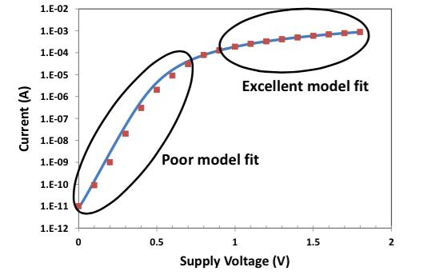
as accurately, and so exis/ng models are inadequate for sub-­‐threshold design, as shown in Figure 2.

Figure 2: Transistors haven't been well modeled

below threshold

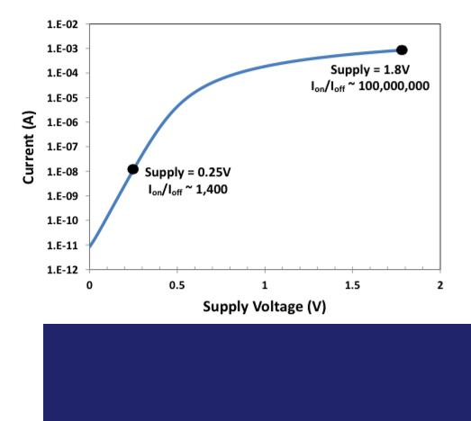

2. Logic swings and noise

The output response of a transistor in the sub-­‐ threshold regime is subtle; detec/ng it requires great sensi/vity. Currents change exponen/ally in response to changing voltages, but they’re exceedingly small currents. In addi/on, the ra/o of “on” to “oﬀ” current is on the order of 1000, orders of magnitude less than what super-­‐ threshold designs experience (see Figure 3). As can be expected, external noise can much more easily interfere with clean opera/on.

Figure 3: The on/oﬀ current ra7o is orders of

magnitude smaller in the sub-­‐threshold regime

!4

Figure 4: Sub-­‐threshold circuits are exponen7ally sensi7ve to temperature
Sub-Threshold Design - A Revolutionary Approach to Eliminating Power

3. Sensi?vity to opera?ng condi?ons

Sub-­‐threshold designs are also far more suscep/ble to process and environmental varia/on than are super-­‐ threshold designs. For example, the current in a slow process corner can be 10-­‐100 /mes less than that for a nominal process. Given that the on/oﬀ current ra/o (above) is only on the order of a thousand, this cannot be ignored.
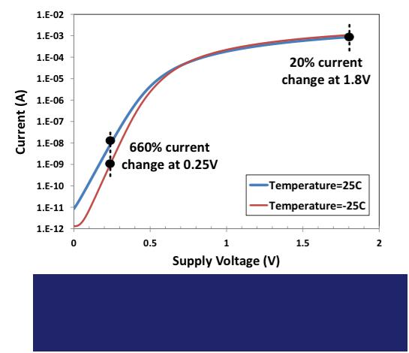

Varia/ons in temperature provide a good example of how environmental condi/ons create a challenge for the designer. V_{th} depends on temperature, and I_{on} depends exponen/ally on V_{th} (as shown in Figure 4

below). As a result, the “oﬀ” current at elevated temperature is similar in value to the “on” current at reduced temperature for an uncompensated circuit.

Sub-­‐threshold circuit design therefore requires extra eﬀort to ensure that the circuits will operate as expected under all specified opera/ng condi/ons.

4. Logis?cal challenges

Much of the manufacturing flow is based upon assump/ons that are reasonable for super-­‐threshold designs but break down for sub-­‐threshold designs. One obvious such challenge can be found in the testers used to validate the silicon during produc/on. The parametric measurement units (PMUs) that test voltages and currents are designed to measure microamps, not nano-­‐ or picoamps.

Even something as straigh_orward as device characteriza/on has to be rethought simply because of the sensi/vi/es that sub-­‐threshold circuits have that super-­‐threshold circuits don’t have. Typical characteriza/on flows may not be thorough enough to prove that the circuits operate properly under all conceivable condi/ons.

The fundamental nature of these challenges, combined with the fact that few engineers are skilled in dealing with sub-­‐threshold issues, explains the challenge of commercializing sub-­‐threshold-­‐based circuits.

Ambiq’s solu?ons

The development of Ambiq’s SPOT technology, which addresses all of these challenges, has been a mul/-­‐ year eﬀort involving mul/-­‐faceted solu/ons, star/ng with a be;er understanding of the transistors themselves.

Ambiq recharacterized selected transistors from mainstream processes in the sub-­‐threshold regime. It was important to start with standard low-­‐power transistors, since the goal was to build these circuits on

!5

Sub-Threshold Design - A Revolutionary Approach to Eliminating Power

standard processes to keep costs down. This recharacteriza/on eﬀort required building numerous devices in order to capture the eﬀects of varia/on and to be;er understand the process and environmental corners, thereby enabling the design of robust circuits.

Once the transistors were be;er understood, cells and circuits had to be modified to operate with sub-­‐ threshold voltages. Before doing this, the cell library was carefully surveyed and pared down. Commercial libraries tend to undergo cell prolifera/on as variants of standard circuits are created for diﬀerent circumstances. So the first job was to select which cells from the library were to be adapted to sub-­‐ threshold opera/on. Once the cri/cal cells were iden/fied, they were then redesigned as sub-­‐ threshold circuits.

There are two goals behind these circuit design eﬀorts. One is to manage the extreme sensi/vity to changes in threshold voltage and opera/ng condi/on, and the other is to op/mize opera/on for minimal energy consump/on. There are a number of techniques that can be employed in both cases, and all of them are important components of the SPOT pla_orm.

Analog circuits, meanwhile, have required addi/onal work. While exis/ng super-­‐threshold digital cells could oeen be modified for sub-­‐threshold use, analog circuits typically required a fresh start. A dispropor/onate eﬀort was put into crea/ng and verifying analog circuits that were substan/ally diﬀerent from their super-­‐ threshold versions.

None of the approaches taken is enough on its own, and none is appropriate in all cases. Ambiq’s circuits are successful because they pick and choose from amongst diﬀerent techniques, applying some or all of them in diﬀerent parts of the integrated circuit. There is no magic formula that dictates what to use where; it takes solid engineering and good design to pull together the right combina/on that provides the required performance with the lowest energy, while at the same /me paying a;en/on to chip area and cost.

This need to use diﬀerent techniques even applies to the type of transistor and the regime within which it will operate. In some cases, super-­‐threshold transistors can make sense. Since super-­‐threshold circuits are simpler, using them where they don’t aﬀect energy consump/on can be beneficial.

A good example of this is the non-­‐vola/le memory (NVM) that can be used to store seongs or calibra/on values while the device is powered down. At power-­‐up, those values need to be loaded into ac/ve registers. Those registers will likely use sub-­‐threshold transistors, but the NVM and the transfer circuits can be designed with standard super-­‐threshold transistors since they operate only at power-­‐up and then are shut down.

The general approach Ambiq uses is to start with sub-­‐threshold transistors as the default approach, and then to review to see if any parts of the circuit can be operated at super-­‐threshold levels without impac/ng energy consump/on. Super-­‐threshold design is simply easier, so it’s preferred if power permits. In most cases, however, power does not permit it; super-­‐threshold circuits are the excep/on.

There are also occasions when cri/cal sub-­‐threshold circuits don’t achieve the required performance. In those select cases, the opera/ng voltage for that island may be raised into the near-­‐threshold region. To date, no circuits have had to go to super-­‐threshold levels to get to the required performance.

!6

Sub-Threshold Design - A Revolutionary Approach to Eliminating Power

So the overall strategy is to use sub-­‐threshold circuits throughout by default, use super-­‐threshold in those few cases where it’s possible, and use near-­‐threshold in those few cases where required for speed or bandwidth.

Ambiq Micro is successful with its sub-­‐threshold circuits because it leverages all of these techniques as needed; this diversity of op/ons is a cri/cal characteris/c of the SPOT pla_orm. In par/cular, Ambiq’s circuits involve the extensive use of dynamic, adap/ve strategies that keep the circuits opera/ng op/mally even as condi/ons change. Sub-­‐threshold design can be frustra/ng, with solu/ons to one problem crea/ng new problems in whack-­‐a-­‐mole fashion. To some extent, it’s simply hard work done by engineers skilled in sub-­‐, near-­‐, and super-­‐threshold design that has allowed Ambiq to be the first company to design circuits that overwhelmingly rely on sub-­‐threshold circuits.

Design and logis?cs impact

A great deal of eﬀort has gone into ensuring that Ambiq’s sub-­‐threshold circuits leverage exis/ng established flows wherever possible. Custom processes might make life easier, but they’re not required, and Ambiq’s focus is on using what is already known to work well.

The design flow was impacted based on the number of custom cell libraries and the sheer number of corners to be verified, given the various design techniques available to manage the circuit sensi/vi/es. These design flow challenges are being encountered in the super-­‐threshold world at the 28-­‐nm process nodes, so solu/ons exist. It’s just that Ambiq has leveraged those solu/ons at more widely available process nodes. Importantly, Ambiq’s SPOT technology can also be scaled to lower geometry processes for even more energy savings as those nodes become more mainstream.

Tes/ng challenges such as the need to measure low currents were addressed by crea/ng complex custom probe cards and on-­‐chip test circuitry. Those cards include specific custom current-­‐measuring circuits that handle the measurements that the tester itself cannot manage.

Finally, the characteriza/on flow had to be much more thorough than what would typically be done for a super-­‐threshold design. It necessitated more detailed measurement under many more condi/ons and combina/ons of condi/ons than would typically be done. The impact of this is greater confidence in the robustness of the product.

n general, no step of the design and manufacturing flow has escaped scru/ny. Where elements of the standard flows have fallen short, Ambiq has modified them to ensure that the resul/ng product is indis/nguishable from something built using super-­‐threshold techniques – with the excep/on of energy consump/on.

Proven reliability

Crea/ng novel circuits means not only building something that works now, but also ensuring that the circuits will operate correctly for the life of the chip. For a system designer, reliability expecta/ons will be the same regardless of the par/cular circuit techniques involved.

!7

Sub-Threshold Design - A Revolutionary Approach to Eliminating Power

For that reason, sub-­‐threshold circuits built on Ambiq’s unique SPOT pla_orm have been subjected to the usual ba;ery of reliability tests, involving mul/ple lots exposed to extreme condi/ons over extended /me periods as well as other standard tests such as electrosta/c discharge (ESD). The circuits have proven themselves to be robust, and reliability reports detailing the results of these tests are available.

Conclusions

The use of sub-­‐threshold techniques can be a powerful way to create circuits that consume drama/cally less energy than those built using standard design prac/ces. It’s a fact that sub-­‐threshold design is diﬃcult. But, given the right experience and diligence, it is a solvable problem, and one that Ambiq con/nues to solve via their patented SPOT technology.

The result of these eﬀorts are circuits that provide the same func/ons as more tradi/onal ones using a frac/on of the energy. There is no compromise in performance, robustness, or reliability; Ambiq’s chips can operate alongside their tradi/onal counterparts with no externally-­‐visible diﬀerence – except for the amount of energy required to drive them. They can provide important energy savings to designers building energy-­‐eﬃcient systems.

Because of the fundamental nature of these innova/ons, sub-­‐threshold design techniques can be applied to virtually any type of IC device. For example, Ambiq demonstrated the viability of this innova/ve approach with the introduc/on of the world’s lowest power real-­‐/me clock (RTC) in 2013. The upcoming release of the world’s lowest power 32-­‐bit ARM-­‐based microcontroller (MCU) further demonstrates the viability of extending these techniques to a completely diﬀerent pla_orm. Ambiq Micro is commi;ed to expanding the SPOT Pla_orm -­‐-­‐ and to giving ba;eries a be;er life.

!8

